Providing Student Supports Through Remote and Hybrid Instruction
Hosted with West Chester Area School District (PA) and Aveanna Healthcare

Tuesday, May 25th, 1-2pm EST

Presenters

Leigh Ann Ranieri Ed.D ( West Chester Area School District)
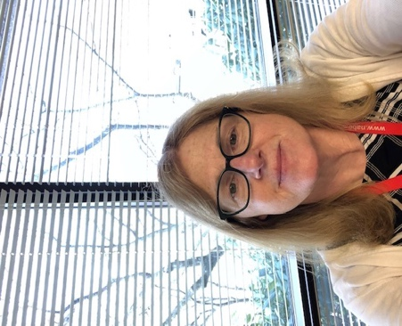

Leigh Ann Ranieri Ed. D., Director of Pupil Services at West Chester Area School District, located in Chester County, Pennsylvania. I have over 35 years of experience in education and have been in my current position for over 11 years. I’m also an adjunct professor in the Educational Leadership program at Cabrini University. I currently supervise special education, counselors, psychologists, social workers, nurses and the English Language Development program. We serve students of diverse backgrounds and have developed a strong foundation of programs to meet the needs of students.

Joyce Chester: WCASD School Board Director

Joyce Chester has served on the West Chester Area School District Board as Director since 2014, most of those years as chair of the Pupil Services Committee and as member of the Education Committee. Ms. Chester is President and CEO of Chester County Opportunities Industrialization Center (OIC), a not-for-profit providing adult literacy and workforce training programs throughout Chester County. Her extensive employment experience includes 20 years of corporate work, over 20 years of non-profit work and overlapping both, 10 years of entrepreneurial work – WriteRight and The Chester Group. Joyce holds a B.A. degree in Organizational Dynamics from Immaculata University and a Masters Certification in Non-Profit Executive Leadership from Bryn Mawr University of Social Work and Social Research. She is also a 2017 graduate of the Pennsylvania African-American Leadership Development Forum and a 1994 graduate of Leadership, Inc. Ms. Chester has two successful sons and one efficacious grandson, all products of WCASD.

David Hunter ( Aveanna Healthcare):

David Hunter serves as the Area Director for the Aveanna Education Services line of business. David has worked in the healthcare management industry for more than fifteen years. A recognized leader within several fortune 500 companies, he has leveraged his achievement and experience to improve client management in multiple business sectors. David has extensive marketing and management experience in the health care industry as well. His focus has been on client development and community outreach. Using innovative initiatives and maximizing on current market trends and exceptional analysis have allowed David to build strong partnerships with clients and within the community. David’s background includes work with non-profit organizations, long term care facilities, and special needs schools.

Kara Fremont (Aveanna Healthcare):
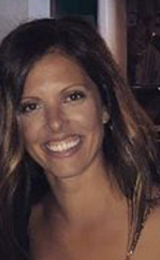
With over 8 years of experience working in the healthcare industry, Kara Fremont , Aveanna Healthcare’s Sales Executive, has been assisting individuals in need in various capacities. Through her work, Kara developed several relationships which have leveraged her ability to bring a critical care child home from the hospital with nursing services, provide a student in school the behavioral support needed and ensure an elderly individual has a home health aide to assist with their activities of daily living. Her focus is on the commitment to individuals and managing all parties at hand. Specializing in client relations, those working with Kara are sure to receive full service and quality care. Kara’s experience is matching Aveanna’s services with specific client needs.

